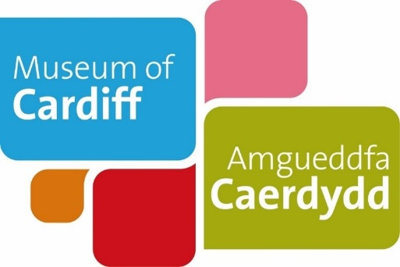
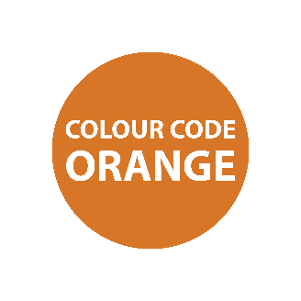
Museum of Cardiff
Life as a child during the Second World War
Teaching Notes
These teaching notes are to be used alongside the pdf or easy read version of the resource. The notes provide additional information to maximise the learning value. They includes suggested follow up activities and links to useful resources.

Life as a child during the Second World War
This activity uses people's personal stories to explore what it was like to be a child in Cardiff during the Second World War, and what it was like to be evacuated.
Possible answers are highlighted in blue throughout the document.
Aims:
Learners will build an understanding of what life was like for children in Cardiff during the Second World War and what it was like to be an evacuee. The activity uses historical sources and personal stories to help learners explore and recognise some of the dangers, challenges and emotional impact that the Second World War had on children’s lives.
Learning objectives:
After completing this resource, learners should be able to:
- Say when the Second World War started and ended.
- Explain why Cardiff was a target for bombing and the understand the definition of the ‘Blitz’,
- Explain the meaning of evacuation and the impact it had on children’s lives.
- Draw comparisons between life during the Second World War and life today.
- Understand how to use personal stories, objects and photographs to explore the past.

Page 1: (insert thumbnail of page)
Life during the Second World War
This page focuses on children’s experiences but you may want to explore some more everyday life themes too, such as ‘home life’ or ‘working life’.

Example idea: Working life
You could explore more about what it meant to be ‘called up’.
‘Called up’ meant that you were called to fight in the war.
At 18 boys were called up to the armed forces and girls to war work.
The Women’s Auxiliary Air Force was the female supporting part of the Royal Air Force during Second World War.
Question idea: What other jobs would people have had during the Second World War?
Possible answers: Women took on roles as mechanics, engineers, munitions workers (working in factories), working on farms, as air raid wardens, bus and fire engine drivers.
Further information about women’s roles during the Second World War can be found here:
www.gov.uk/government/news/the-women-of-the-second-world-war

Take a look at our online collections catalogue for ‘working life’ objects.
Collections Online web link: https://collections.cardiffmuseum.com/ais6/search/simple
Example object: https://collections.cardiffmuseum.com/ais6/Details/collect/1041

Image description: This ticket holder was introduced by Cardiff Corporation in 1938/1939, making it easier for conductors to issue tickets. The ticket holder is made out of metal with a black fabric strap attached to it.
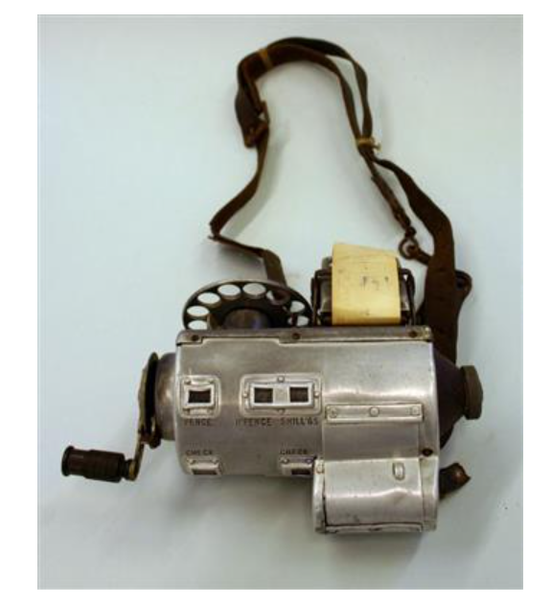
Additional activity idea:
Critical thinking activity.

You could find examples of recruitment posters from that time and ask questions.

- What is the message? What do you think the poster is trying to say?
- What words and pictures are on the poster and why?
- How does the poster make you feel?

Additional activity idea:
See, think and wonder activity.

There are three historical photographs within the pdf resource. You could use a ‘See, think and wonder’ activity to further explore these images.

This activity supports the development of pupil’s personal effectiveness, building emotional intelligence and debating skills.

Images in pdf resource and described in the easy read word document.
1. Evacuees from Bristol to Kingsbridge, Devon, 1940. (© Imperial War Museum)
2. Llandaff Cathedral damage. (© Cardiff Libraries)
3. Evacuees from London in Pembrokeshire, Wales, 1940. (© Imperial War Museum)
Example: Look at the image of: “Evacuees from Bristol to Kingsbridge, Devon, 1940.”
Question: What do you see/ think/ wonder when you look at the photograph?
Possible answer:
- What do you see- They are wearing tags on their clothing.
- What do you think – How long were they evacuated for? Why were they evacuated? Example evacuee stories are include in the pdf. Stories from Joyce and W.P.
- What do you wonder – How were they feeling? The children look happy in the photograph but do you wonder if they were feeling excited/ sad/ afraid?

Additional information
Why did evacuees wear tags on their clothing?
Children who were being evacuated would have a label attached to their clothing. The labels had information about the children written on them. When the children got to the places that they were being evacuated to, people there would know who the children were and where they had come from.
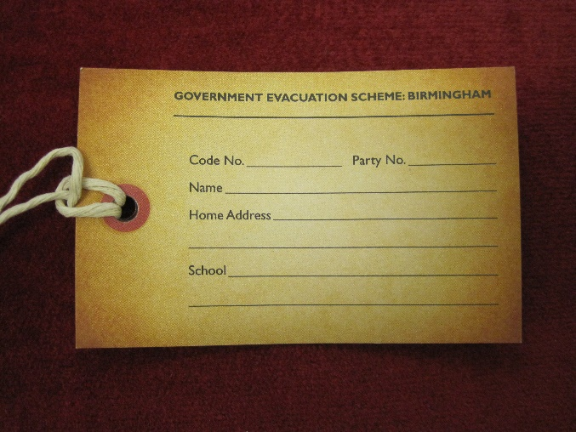
Image decription – This is a replica of an evacuee label. The label is yellow and made out of paper with a bit of sting attached to the end of it, so that it can be tied to a jacket.
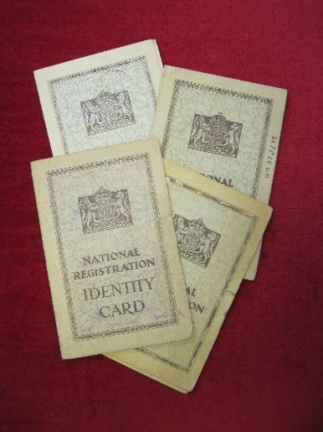
Image descripotion: These are National Identity Cards for people aged 16 and under. They are green and made out of paper with a government logo on the front of them.

What were National Registration Identity Cards?
Everyone, including children, had to have their identity card on them at all times during the Second World War. The identity cards were given out by the government and had the owner’s name, address and any change of address on them. If a child was evacuated, the card would have their new address on it.

References, useful contacts and information:
Museum of Cardiff collection
Glamorgan Archives- For further information email: glamro@cardiff.gov.uk
Cathays Heritage Library: For further information email: cathaylibrary@cardiff.gov.uk
Imperial War Museum collections: https://www.iwm.org.uk/collections
Dennis Morgan, Cardiff a City at War (1998)
Nigel Alan Robins, Eye of the Eagle: Luftwaffe Aerial Photographs of Swansea (1994.)
www.gov.uk/government/news/the-women-of-the-second-world-war

