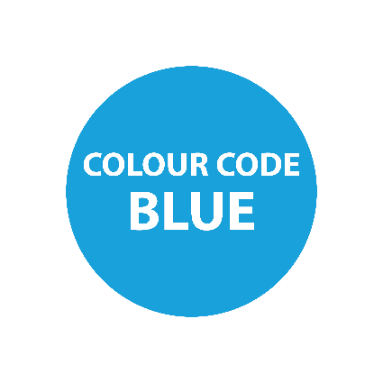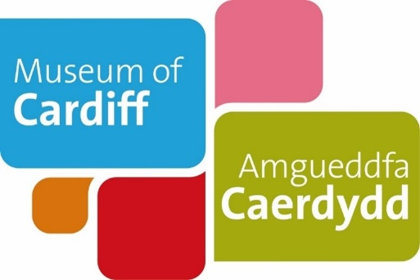

Museum of Cardiff
Life as a child during the Victorian Period
Teaching Notes
These teaching notes are to be used alongside the pdf or easy read version of the resource. The notes provide additional information to further support pupils learning. They include suggested follow up activities and links to useful resources.

Life as a child during the Victorian Period.
This activity uses people's personal stories to explore what it was like to be a child in Cardiff during the Victorian Period.
Possible answers are highlighted in blue throughout the document.
Aims:
Learners will build an understanding of what life was like for children in Cardiff during the Victorian period.
Learning objectives:
After completing this resource, learners should be able to:
- Say when the Victorian period started and ended
- Understand how the docks industry led to Cardiff growing as people moved for new jobs and opportunities.
- Draw comparisons between life during the Victorian period and life today.
- Understand how to use personal stories, objects and photographs to explore the past.
Page 1: Cardiff docks

Historic photo activity idea:
Look at the photograph of the East dock in 1883 on page 1 of the pdf resource.
Question: What do you notice in the photograph?
This is a good way of getting the pupils to explore how we can use photographs to find clues about the past. E.g. is there a date on the photograph?
Possible answers:
The photo is black and white – it’s an old photograph.
There’s writing on the bottom of the photograph – it says the name of the dock and date.
There’s lots of ships – it shows that the docks were busy then.
Why not explore more objects from Cardiff Docks using the Museum of Cardiff collections website: https://collections.cardiffmuseum.com/ais6/search/simple
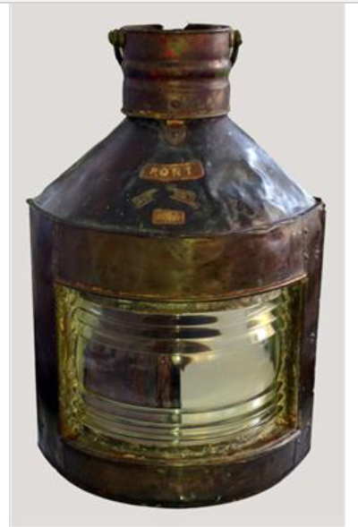
https://collections.cardiffmuseum.com/ais6/Details/collect/754
This lamp was probably taken from a ship by the staff of Frazer's Ships Chandlers when it was replaced by a new one from their stores. Frazer's opened in the 1880s and supplied everything a ship would need to go to sea - from maps, ropes and sails to food, medical supplies and anchors!
Page 2:
Children’s rights
This page mentions some of the changes to children’s rights brought in during the Victorian period.
Question idea: What are rights?
This activity would be a good means of building in active citizenship, new curriculum relevance’s.
Simple definition of rights:
Rights are something a person has which people think should not be taken away. It is a rule about what a person is allowed to do or have. ... Rights can be put into laws, so they have legal protection.
For further reading you could use the UN Convention on the Rights of the Child: https://www.unicef.org.uk/what-we-do/un-convention-child-rights/
Page 4 & 5:
Victorian home life
Example idea:
This pdf and easy read resource uses stories and objects that were used in Victorian homes in order for learners to be able to make comparisons between things used today. For instance, candle stick holders were used in most Victorian homes as there was no electric lighting until the 20th century. This helps us explore changes in the technology used in people’s every day, home life.
Example activity:
After reading Mary’s story. Look at the list of objects on pages 4 & 5 of the PDF or easy read resource:
Question: What modern day objects would you use today to do the same job at home?
Possible answers: Carpet beater = vacuum cleaner, candle stick holder = electric lighting, a torch…
Question: How have these modern objects changed the way that we do things at home?
Possible answers: Cleaning your home takes less time, we have electric in our homes now.
Take a look at our online collections catalogue for more ‘home life’ objects.
Collections Online web link: https://collections.cardiffmuseum.com/ais6/search/simple
Example object: https://collections.cardiffmuseum.com/ais6/Details/collect/753
Object Image description
This is a ceramic water filter, it was used by John Penn and his family in their house in Grangetown during the late 19th and early 20th century.
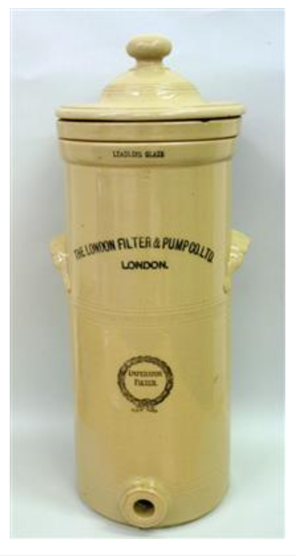
﻿﻿In Victorian times Cardiff’s drinking water was of poor quality and a danger to health. Drinking water came from the Glamorganshire Canal or the River Taff, where the town’s sewage was dumped. Cardiff suffered several cholera outbreaks in the 19th century; the worst was in 1849 when over 350 people died. Although improvements had been made by the late 19th century people continued to use water filters to remove impurities and improve the taste of the water.
Example follow up questions idea:
What do we use today to keep ourselves healthy?
Example answers: medicines, regular exercise, You could reference recent COVID-19 items that are made to keep us safe- PPE, masks, hand sanitiser.

References, useful contacts and information:
Museum of Cardiff collection
Glamorgan Archives- For further information email: glamro@cardiff.gov.uk
Cathays Heritage Library: For further information email: cathaylibrary@cardiff.gov.uk
Dennis Morgan, The Cardiff Story: A History of the City from its Earliest Times to the Present (1991).

