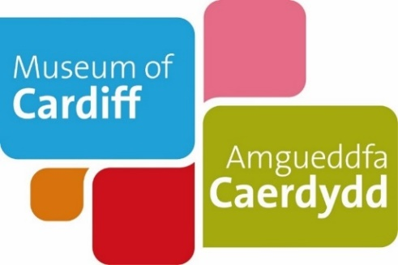
Museum of Cardiff
Life as a child: Then and now
Teaching Notes
These teaching notes are to be used alongside the pdf or easy read version of the resource. The notes provide additional information to maximise the learning value. They includes suggested follow up activities and links to useful resources.

Life as a child: Then and now
This activity uses memories of growing up in Cardiff to explore how children made their own fun in the past compared to today.
Possible answers are highlighted in blue throughout the document.
Aims:
Learners will build an understanding of what life was like for children in Cardiff in the past and compare it to their experience of playing and growing up today. The activity is designed to develop learner’s communication and critical thinking skills building understanding of how we can use different personal stories and objects to explore your local heritage.
Learning objectives:
After completing this resource, learners should be able to:
- Explain what ‘Make do and mend’ was.
- Understand how we can use historic principles like ‘make do and mend’ to be sustainable and environmentally conscious.
- Draw comparisons between life growing up in the past and life growing up today.
- Understand how to use personal stories, objects and photographs to explore the past.

Page 1:
This page focuses on children’s experiences but you may want to explore some more objects used for leisure time.
Example idea:
You could explore some more stories about leisure time activities that people enjoyed in the past and compare them.
Take a look at our online collections catalogue for ‘leisure time’ objects.
Collections Online web link: https://collections.cardiffmuseum.com/ais6/search/simple
Example object: https://collections.cardiffmuseum.com/ais6/Details/collect/2454
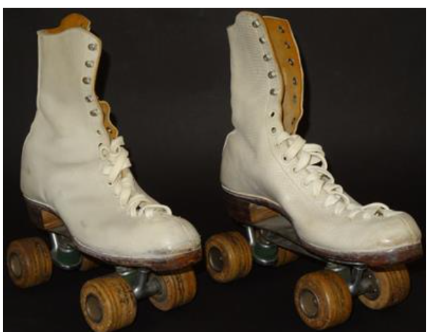
Image description: White roller skates worn by Josephine Eames while roller skating at the Embassy Skating Rink in Cathays.

Josephine remembers: “I used to go to the Embassy in my late teens in the 50s a few nights a week. I went to a dancing class there and got a medal. Sometimes you’d dance on your own, sometimes with other people… It was one of the main things I did for leisure. Even as a kid I had skates with steel wheels. I would skate around the street and steal my brother’s skates.”
Additional activity idea:
To complement this resource, you could explore the resources available on Play Wales: https://www.playwales.org.uk

Play Wales campaigns for the importance of play in supporting children’s wellbeing, developing their resilience and flexibility.

There’s resources available about The United Nations Convention on the rights of the child – Article 31 here: https://www.playwales.org.uk/eng/article31resources

This can aid conversations around active citizenship and building understanding of the rights of the child.

Oral history guide
To finish exploring the then and now theme, ask the museum for a ‘Detective Dewi and Historian Heledd’s oral history guide’. You could ask pupils to work in pairs and interview each other about their experience of playing and growing up today.

References, useful contacts and information:
Museum of Cardiff collection
Glamorgan Archives- For further information email: glamro@cardiff.gov.uk
Cathays Heritage Library: For further information email: cathaylibrary@cardiff.gov.uk
Play Wales: www.playwales.org.uk

