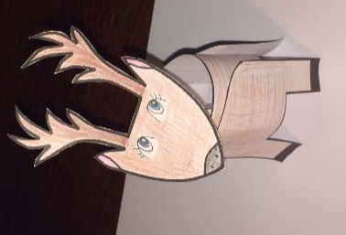
Museum of Cardiff craft guide - Make your own Reindeer
Image caption: Photograph of an example, finished paper reindeer. The reindeer is made from five paper templates, and once created, stands an unaided three dimensional reindeer. The reindeer is coloured in a light brown pencil. The reindeer has a rounded triangle face that is secured just above the body using a paper support. The reindeer has large, pencilled on, blue eyes in the top centre of the face, and long eyelashes. At the bottom tip of the face is the reindeers black round nose. On the top left and right of the reindeer's head are its antlers. The reindeer’s body is a cylindrical shape, and its front and back legs are taped either side. The bottom of each leg has small black rectangular detail.

You will need:
- A printed copy of the reindeer template.
*If you can’t print the template, you can make your own by drawing the 5 shapes onto a sheet of paper. Please read the description of the reindeer pieces shapes at the end of this document for further guidance.*
- Pencil crayons
- A pencil
- Scissors
- Sticky tape
Step One:
Use the pencil crayons to colour in your reindeer template in your chosen colours. Why not be creative with different colours! What expression does your Reindeer have?
Step Two:
Using your scissors, cut out the 5 pieces from the reindeer template and lay them out in front of you – you may need an adult to help you with the cutting out, be careful as scissors are sharp.
Step Three:
Wrap the long rectangular shaped piece together until the end meets the dotted line, (making a cylinder shape), the dotted line is approximately one centimetre from the end. Tape across the dotted line in place. This will be your reindeer’s body.
Step four:
Use sticky tape to stick the front and back leg pieces to each end of the cylinder (the reindeer’s body.) Your reindeer should now be able to stand unaided.
Step Five:
The smallest rectangular piece is your reindeer’s neck.
Now, using sticky tape, stick your reindeers head to its neck.
Then, with your reindeer’s body standing upright, stick the head and neck to the reindeer’s body. Stick the neck in the inner centre of the body.
Step six:
Name your Reindeer! Why not take a photo or draw a picture of your reindeer and share it with us at Museum of Cardiff? Email: cardiffstory@cardiff.gov.uk

*If you wish to draw your own shapes: The shapes are: one long and wide rectangle (the body), one small rectangle (the neck), two rounded square pieces that act as the legs, with the centre bottom cut away so the legs are more prominent and allow the reindeer to stand upright. Finally, a rounded triangle piece as the head, with antlers at the top.

